Beirut, September 2017 —

The Sursock Museum is pleased to announce the opening of two new exhibitions: Eight Stories from the Sursock Museum Collection and Partitions et Couleurs : Hommage à Amine El Bacha.

Both exhibitions open on Thursday 14 September 2017, from 18:00 to 21:00.

Eight Stories from the Sursock Museum Collection | Collection Galleries, Level 2
Opening on Thursday 14 September 2017, from 18:00 to 21:00

The Sursock Museum’s permanent collection consists of works acquired by or donated to the Museum since it first opened in 1961. The collection is mainly composed of paintings, graphic works, sculptures, and other three-dimensional objects.
This new hang of the permanent collection takes the form of eight stories told by 23 artists. They, at times, are in dialogue around a specific theme, or else reject and disregard one another. The stories are inspired from research in the Sursock Museum’s archives. This by no means exhaustive research evokes a history fragmented in time and space, comprised of eight chapters which open up to a broader reflection. An additional section is dedicated to recent acquisitions and donations, to be exhibited in rotation.
For more information about Eight Stories, please contact Muriel N. Kahwagi [muriel.kahwagi@sursock.museum].

Partitions et Couleurs : Hommage à Amine El Bacha | Collection Galleries, Level 1
In collaboration with the Amine El Bacha Foundation
With the support of Banque Libano-Française
Opening on Thursday 14 September 2017, from 18:00 to 21:00
On view until 12 March 2018
Partitions et Couleurs : Hommage à Amine El Bacha is the first exhibition in a cycle of homages to artists represented in the collections of the Sursock Museum. This series of exhibitions is supported by Banque Libano-Française.
This tribute brings together a series of oil paintings, watercolors, and painted wooden objects created between the 1960s and the first decade of the 21st century.
The works in this exhibition, selected from amongst a considerable oeuvre that tackles a range of subjects in a range of materials, are grouped into four main categories: abstractions and landscapes; the fantastical; religion and the Last Supper; and music. These works showcase the transformations in El Bacha’s artistic trajectory: from abstract moods bordering on freeform expression to an aesthetic stylization of melodious, improvisational color that establishes a new world of harmony in the composition of form.

A 16-page publication accompanies the exhibition, featuring an essay written by the artist and art critic Fayçal Sultan.

Amine El Bacha
b. 1932, Beirut, Lebanon – Lives and works in Beirut, Lebanon

Amine El Bacha’s work spans painting, illustration, sculpture, and writing. He completed his studies at the Acad.mie Libanaise des Beaux-Arts (ALBA) in 1957, and in 1959, received a scholarship from the Embassy of France to pursue his studies in Paris at the .cole Nationale Sup.rieure des Beaux-Arts and the Académie de la Grande Chaumi.re. El Bacha’s illustrations have been featured in numerous poetry volumes, including Alain Jouffroy’s (1965), L.opold Sédor Senghor’s (1978), and Nadia Tueni’s (1983). His body of work also encompasses mosaic, tapestry, and jewelry – notably, the mural of Club des Artistes, Vincennes, France, and the mosaic of the church of San Martino, Legnano, Italy. His work has been exhibited widely, including at the Alexandria Biennale; the National Museum of Modern Art (Paris); the 6th Conches Biennale (Paris); and the Kreisler Gallery (Madrid). Major prizes include the Love Prize and the Citt. Eterna Prize.

Fayçal Sultan
b. 1946, Tripoli, Lebanon – Lives and works in Beirut, Lebanon

Fayçal Sultan is an artist, art critic, and researcher. He earned his foundational training in painting and photography at the Lebanese University’s Institute of Fine Arts, and completed his Ph.D. in visual arts in Paris in 1988. His writings have been featured in several publications, including 400 Years of Freedom Culture and L’art Au Liban : Artistes Modernes Et Contemporains 1880-1975 (2012). He’s also published a mongograph titled A Collection of Writings on Art in Beirut (2013), bringing together a selection of articles and studies written in Assafir from 1976-1993.
For more information about Partitions et Couleurs, please contact Muriel N. Kahwagi [muriel.kahwagi@sursock.museum].
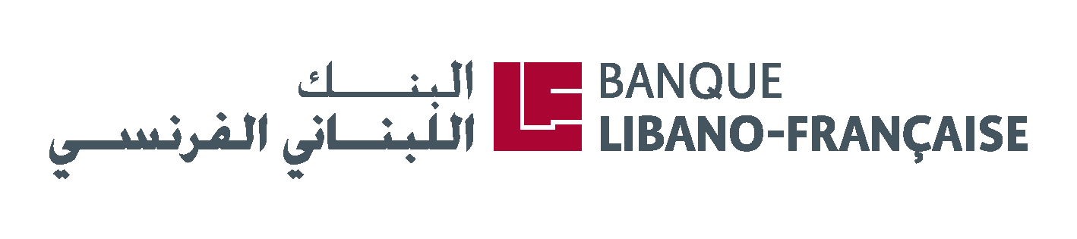
About the Sursock Museum
Mission
The Nicolas Ibrahim Sursock Museum is a modern and contemporary art museum in the center of Beirut first opened in 1961, with a mission to collect, preserve, and exhibit local and international art.

Through our collection, archives, exhibitions, and public programs, we aim to produce knowledge on art practices in the region and explore work that reflects on our contemporary moment. Our goal is to support local art production, to provide a platform for encounter and experimentation with art and ideas, and to inform and challenge different audiences in new and unexpected ways.

Admission and opening hours
Open daily from 10:00 to 18:00
Late opening on Thursdays from 12:00 to 21:00
Closed on Tuesdays
Admission to the Sursock Museum is free of charge.

Address
Greek Orthodox Archbishopric Street
Ashrafieh 2071 5509
Beirut, Lebanon
T +961 1 20 20 01
www.sursock.museum
info@sursock.museum

Press contact
Muriel N. Kahwagi, Head of Communications
muriel.kahwagi@sursock.museum

